**Crime analysis and prediction using optimized and k-means algorithms**

Abstract:-

The report adds that the cases of murder, rapes, and kidnapping have seen a rise. Most of countries in the world have seen a remarkable increase in the crime rate. There is no particular reason for any trouble for criminal activities. To prevent this problem in police sectors have to predict crime rate using machine learning techniques. The aim is to investigate machine learning based techniques for crime rate by prediction results in best accuracy and explore in this work the applicability of data technique in the efforts of crime prediction with particular importance to the data set. The analysis of dataset by unsupervised machine learning technique(USMLT) to capture several information’s like, variable identification, uni-variate analysis, bi-variate and multi-variate analysis, missing value treatments and analyze the data validation, data cleaning/preparing and data visualization will be done on the entire given dataset. Our analysis provides a comprehensive guide to sensitivity analysis of model parameters with regard to performance in prediction of crime rate by accuracy calculation from comparing unsupervised clustering machine learning algorithms.

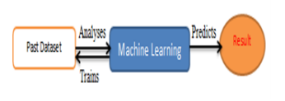

Process of machine learning algorithms

Flow diagram of machine learning algorithms:-

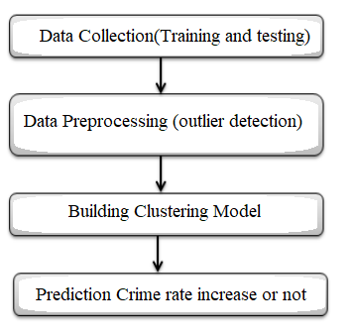

Existing system:-

Based on the previous year crime details in Indian states, It present statistical models through Weighted Moving Average, Functional Coefficient Regression and Arithmetic-Geometric Progression based prediction of the crime in coming years. Difference between actual records and our predicted values for both years gives the accuracy of the proposed approaches between the range 85% and 90%. In future, this work can be modified by using Machine Learning (ML) models for forecasting crime, as the data points will sufficiently increase to apply ML models. This can also increase the accuracy of the predictions. Further, statistical modeling’s methods can also be clubbed with ML models and then calculate weighted accuracy for a district, this can make the solution more robust.

Disadvantages:

Although some approaches and some detection techniques are present like women safety security system in iot and embedded ,there may be some accuracy problems .

Proposed system:-

There are many machine learning algorithms available to users that can be implemented on datasets. However, there are two major types of learning algorithms: supervised learning and unsupervised learning algorithms. The clustering algorithms are given a particular attribute or set of attributes to predict. Data preprocessing process includes methods to remove any null values or infinite values which may affect the accuracy of the system. The main steps include Formatting, cleaning and sampling.

Crimes Prediction ways:

* To utilize the resources identify the hotspots of crimes and allocate vigilante resources such as policeman, police cars, weapons etc. reschedule patrols according to the vulnerability of a place.
* So, that avoids crimes Ensure better civilization through avoiding happening crimes such as murder, rapes, thefts, drug, smugglings etc.

System architecture:-

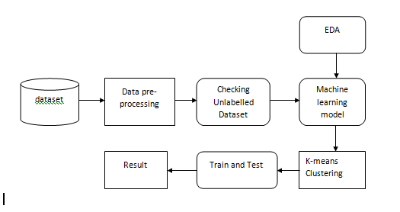

Advantages:-

* Accuracy of prediction of crimes rates increases .
* Safety and security of people around us. Thus machine learning algorithms also helps in safety and security system.

System requirements:-

Software and Hardware Requirements:

Hardware:

OS – Windows 7, 8 and 10 (32 and 64 bit)

RAM – 4GB

Software:

Python

Anaconda